**MCQ**

**1.** resize

The resize property defines if (and how) an element is resizable by the user.

Answer => resizeable by users.

2. Perspective

Which should have perspective to change to 3-D

<div class=”container”>

<div class=”box”>

image

</div>

</div>

Answer => .container{perspective :100px}

3. Transform

div.c {

width: 100px;

height: 100px;

background-color: yellow;

transform: rotate(45deg) scale(1.5) translate(20,30);

}

Answer=> div move (150px x 150px) right down

4. Background

Integer simplifies what?  
 body {

background: url("img_tree.gif") 10px 20px;

}

Answer => left top

5. css div

.p{color: ‘red’}

Answer=> all div tags with className = ‘p’

6. Css child

.p(2n+2){

}

Answer => div starting from 2,4,6,8 tags

7. Css combinators

div.p

div+p

div~p

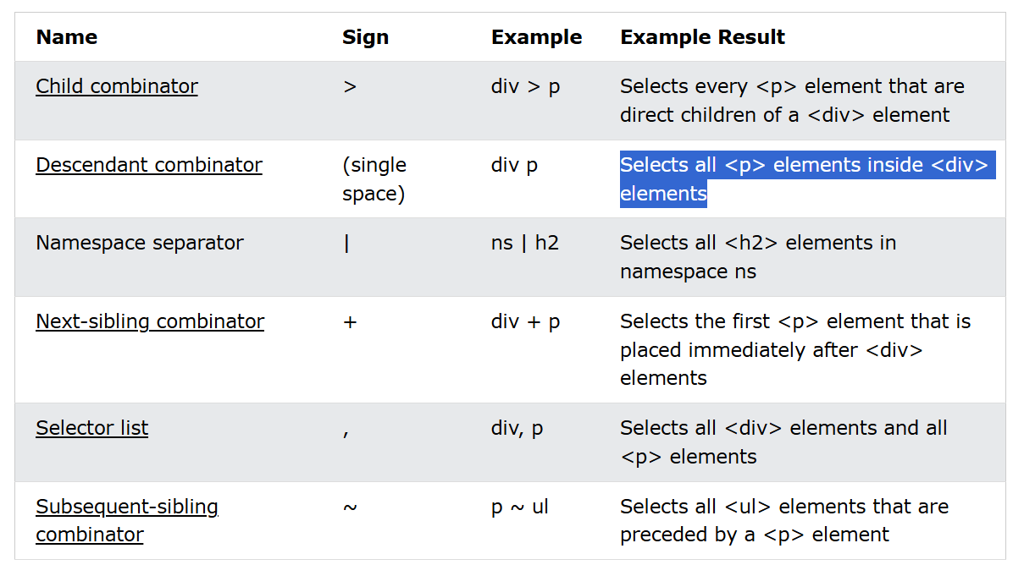

**Answer =>** Selects all <p> elements inside <div> elements

8. Mapping

Access one item and update it

i)Transaction.map ii)Transaction.forEach iii) transaction.filter iv)transaction.some

Answer=> Transaction.map (or) Transaction.forEach

9. Object creation

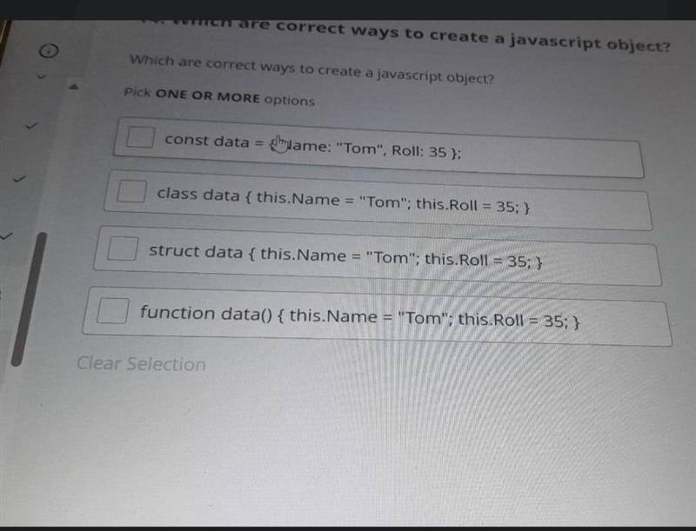

Answer => 1st and 4th

10. Class

Class Salary (salary){

Let base = salary;

addBonos(amount): { base += amount }

getSalary () :{return base}

}

Const employee = new Salary(50000)

Employee.addBonus(5000)

Employee.getSalary()

Answer => 55,000

11. Object   
 show total

i) forEach() ii)for() iii) map().reduce iv)---------   
  
Answer=> map().reduce

12. Code Optimasation

Which is best

i) For loop 4lines ii) map().filter iii) while iv) forEach()

Answer => map().filter

13. DOM rendering

i) all DOM and external file renders jointly

ii) first DOM content renders then external file renders

ii) ---- iv) -----

Answer => first DOM content renders then external file renders

14. Animals communicate (more questions)

makeCommunicate()

last function.

15. HOC

const A = ({name:"hello"}) => {

  return <></>

}

const B = <A gretting={"hello"}/>

export default function App() {

  return (

    <div>

      <B name={"hello"}/>

    </div>

  );

}

1. Undefined ii) error iii) hellohello iv) -----

Answer => hellohello

16. Props

App.js

<test pass={"Test"} children=”hello”>

<p>hi</p>

</test>

Test.js

<div>

<p>{props.pass}</p>

<p>{props.children}</p>

</div>

Answer => hi

17. React render

function HelloWorld() {

return <span>Hello, World!</span>;

}

ReactDOM.render(<HelloWorld />, document.getElementById('root'));

Answer => span tag renders, type=>component

18. Psecudo code   
  
 print the console in correct order

Note:Timeout will console at last

Answer =>Start, Data processing, End , Data fetched(timeout console)